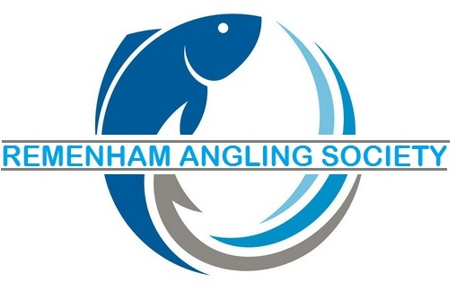
Henley & Shiplake Waters
MEMBERSHIP APPLICATION FORM
SEASON 2024/2025
FIRST NAME ……………………………………………………………………… Membership number RAS.................
SURNAME …………………………………………………………………………………
ADDRESS ……………………………………………………………………………………………………………………………………….
…………………………………………………………………………………………………………………………………………………………….
………………………..………….COUNTY………………………………………………………..POSTCODE ……………………………..
TELEPHONE NO…………………………………………………..MOBILE…………………………………………………………………..
E-MAIL ADDRESS ..................................................................................
VALID (CURRENT) ROD LICENSE NO ………………………………………………………………………. (MANDATORY).
(INSERT YOUR EA PURCHASE REF NUMBER IF LICENSE NOT YET RECEIVED )
AGE AS AT 1ST APRIL 2024…………………………………………………………………………………
PLEASE TICK
FULL/SENIOR REMENHAM PERMIT £30.00
CONCESSIONARY (OVER 65 OR REGISTERED DISABLED) £20.00
JUNIOR (UNDER 16 AS AT 1ST APRIL 2024) £15.00
TOTAL :
CHEQUES MADE PAYABLE TO: REMENHAM ANGLING SOCIETY
DECLARATION. I, the undersigned, hereby agree to adhere to the constitution and all the rules of the Society

SIGNED… ………………………………………………………………………………………………DATE ………………………………………………………………….
If under 16 years old – Parent/Guardian to sign above and denote name here
………………………………………………………………………………………
APPLICATIONS BY POST TO: Andrew Crook 13 Simmons Road Henley on Thames Oxon RG9 2ER

